experiment 10

COMPUTER GRAPICS AND MULTIMEDIA

# Aim

To bounce a ball using animation.

**Syeda Reeha Quasar**

**14114802719**

**3C7**

# **EXPERIMENT - 10**

**AIM:**

To bounce a ball using animation.

**To bounce a ball using Key frame Animation.**

STEPS:

Step 1: Select 'Animation' from main menu bar.

Step 2: Click 'Create' on Maya title bar and then click on 'Polygon's primitives' and then click on 'Sphere'.

Step 3: Click 'Move' tool to move the ball to position in a frame.

Step 4: Fix the position of the ball in a frame by pressing the 'Set key(Shortcut-S).

Step 5: Move to the next frame and set another position of the ball using Set key.

Step 6: Click 'Play' to view the moving ball.

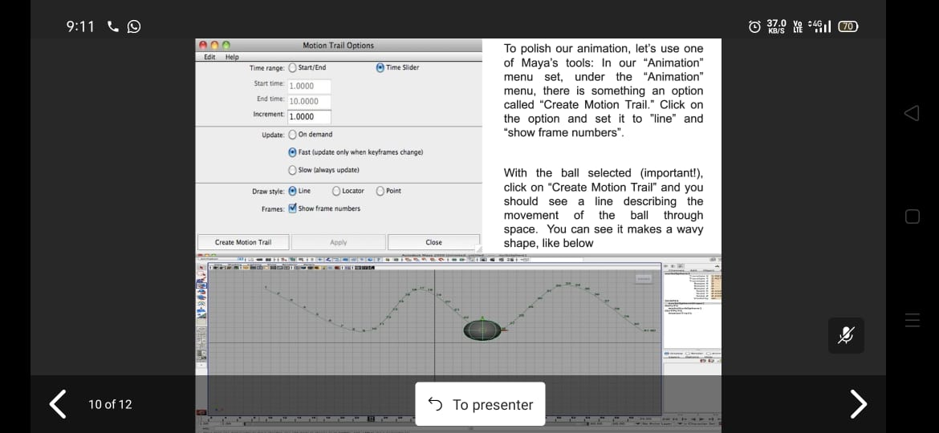

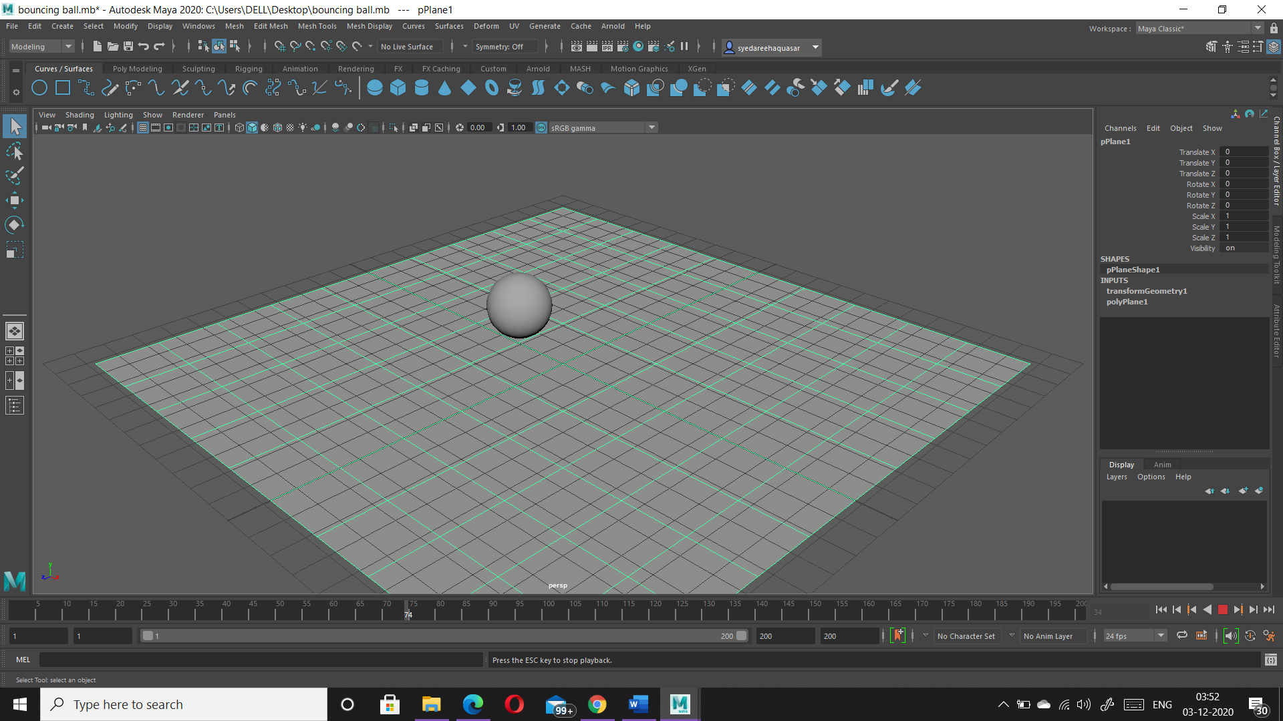**Animation Screenshots**